# Assignment: CSE211 Web Programming, Fall Semester 24/25

# Assignment #1: Websites Conceptual Design and Mock-up

# 221101215, Marco Makram Barty

# Core Idea of the Assignment

Developing a website that meets the needs of users in an intuitive, secure, and efficient manner is crucial in today’s digital landscape. The flight booking website in this project aims to provide travelers with a seamless booking experience by offering real-time data, secure payments, and personalized recommendations. This report explores the steps in designing and developing this platform from concept to deployment..

# Section 1: Research – Evolution of Web Design in Online Travel

Defining Characteristics of Web 2.0 to Web 4.0:

**Web 2.0**: Introduced social networks and user-generated content, emphasizing the power of networked communities.

**Web 3.0**: Shifted to semantic web technologies, allowing for intelligent data processing, personalization, and enhanced search capabilities.

**Web 4.0**: Focuses on intelligent systems using AI, supporting predictive capabilities and adaptive content.

**Key Features of Web 2.0**: Network power was amplified through interactive sites where users could create, share, and consume content, forming social networks and communities that facilitated collaboration and connection.

**Key Features of Web 3.0**: Enhances the meaning of data and creates knowledge connections, utilizing semantics and AI to interpret data contextually, which is integral for personalized and accurate search results.

**Key Features of Web 4.0**: Centers on intelligent connections, allowing adaptive and context-aware experiences powered by AI, significantly improving usability in platforms like the flight booking website project.

**Importance of Collective Intelligence and Social Media**: These elements foster collaboration, innovation, and information sharing, supporting modern business applications that require user insights and community feedback.

**Empowering Business Plans with These Technologies**: Technologies from Web 2.0 to Web 4.0 influence e-commerce by enhancing user engagement, data processing, and prediction-based decision-making.

**Application of Latest Technologies in Profession**: Skills from this project, such as database management, secure transaction handling, and real-time data updates, are transferable to numerous sectors, including e-commerce and travel tech.

# Section 2: Website Planning Analysis – Flight Booking Platform

**Purpose of the Website**: To facilitate efficient and reliable flight bookings for travelers by providing a user-friendly platform with real-time information.

**Goals of the Website**: Enable users to search, compare, and book flights seamlessly.

**Intended Audience**: Primarily travelers of varying age groups who require a streamlined online booking experience.

**Issues Addressed**: Simplifies the booking process and offers reliable flight information to avoid inconsistencies.

**Content Types**: The site includes text, images, interactive elements, and database-driven content (e.g., flight schedules, prices).

**Serving the Client**: Provides accurate, up-to-date flight options and secure payment gateways.

**User Interaction Methods**: Forms for flight search and booking, secure logins, and personalized user dashboards.

**Function Discovery**: Clear navigation bar and search functions make it easy for users to access main features.

**Data Handling**: Once users submit a booking, data is stored securely for both tracking and future use.

**Data Usage by Receiver**: Enables administrators to manage flight options, booking history, and user preferences.

**Result Handling**: All booking and registration data is securely managed, ensuring user privacy and accessibility.

**Follow-up**: Customers receive booking confirmations and follow-up emails.

**Similar Sites**: Sites like Booking.com and Expedia, chosen for their user-friendly interface and efficient booking process.

**Planning Analysis Sheet**:

**Website Goal**: Provide a convenient flight booking platform.

**Page Titles (Example)**: Home, Flights, About Us, Contact, User Dashboard, Booking History, FAQ, Admin Panel.

**Content for Each Page**:

Home: Introduction and main booking search feature.

Flights: Flight options, prices, and search filters.

User Dashboard: User-specific content like booking history and preferences.

Admin Panel: Allows admins to update and manage flight information.

**Forms**: Registration, flight search, and booking forms are utilized.

**Flowchart**: A simple hierarchy placing the home page as the root, branching into categories like Flights, Dashboard, and Admin Panel.

**Wireframe**: Layout sketches showing navigation, booking interface, and user sections.

# Section 3: Website Design Concepts (Gestalt Principles and Additional Design)

**Gestalt Web Design Principles**:

* **Law of Prägnanz**: Simplify content presentation for quick understanding.
* **Closure**: Group related icons for easy navigation.
* **Symmetry and Order**: Create a balanced layout to improve usability.
* **Figure/Ground**: Use whitespace to enhance the visibility of main features.
* **Uniform Connectedness**: Link navigation elements to provide visual consistency.
* **Common Region**: Use boxed sections to separate functions.
* **Proximity**: Space related elements closely together, like search options.
* **Continuation**: Guide user flow through logical page transitions.
* **Common Fate**: Group icons with similar actions, such as search and filter options.
* **Parallelism**: Use parallel visuals to represent related sections, like “My Flights” and “Booking History”.
* **Similarity**: Ensure consistent styling for elements like buttons and headings.
* **Past Experience**: Users familiar with booking sites will easily navigate this layout.

**Additional Design Concepts**:

* **Screen Resolution**: Design a responsive site for devices with different resolutions.
* **Color Palette**: A color scheme that enhances readability and aligns with travel themes.
* **Contrast for Accessibility**: Ensure minimum contrast ratios are met.
* **Front-End Technologies**: HTML, CSS, JavaScript.
* **Content Management Systems (CMS)**: Use of a CMS for dynamic content if necessary.
* **Back-End Technologies**: MySQL for database management, secure backend with PHP or Node.js.
* **Performance Metrics**: Page load times, user engagement, and error rates.
* **HTML5 Structure**: Organize each page with headers, footers, main content, and navigational sections
* 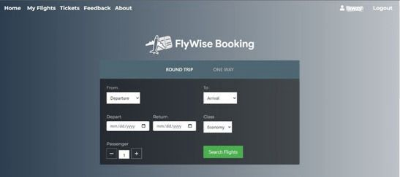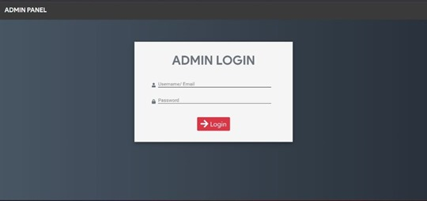

# References

• **Berners-Lee, T., & Fischetti, M.** Weaving the Web: The Original Design and Ultimate Destiny of the World Wide Web by Its Inventor. Harper Information, 1999.

Discusses the history and evolution of the World Wide Web from its creation, providing insight into early internet concepts and the progression to Web 2.0 and beyond.

• **DiNucci, D.** “Fragmented Future.” Print Magazine, vol. 53, no. 4, 1999, pp. 32-35.

This article first introduced the term “Web 2.0,” exploring the idea of an interactive web focused on user experience and content.

• **O'Reilly, T.** “What Is Web 2.0: Design Patterns and Business Models for the Next Generation of Software.” O’Reilly Media, 2005.

A seminal paper defining Web 2.0 and explaining the shift from static to dynamic, user-centered websites.

• **Gartner Research**. Top 10 Strategic Technology Trends for 2021: The Next Generation of the Digital World. Gartner, 2021.

Provides analysis on Web 4.0 technologies, artificial intelligence, and the shift toward adaptive and intelligent interfaces.

• **W3C (World Wide Web Consortium)**. Introduction to Web Accessibility. Available: <https://www.w3.org/WAI/fundamentals/accessibility-intro/>

This source outlines design principles focused on accessibility, which is essential for modern website design, including compliance with Web Content Accessibility Guidelines (WCAG).

• **Nielsen, J.** “Usability 101: Introduction to Usability.” Nielsen Norman Group, 2003. Available: https://www.nngroup.com/articles/usability-101-introduction-to-usability/

A foundational reference on web usability and user-centered design, detailing key principles that improve the user experience.

• **Krug, S.** Don't Make Me Think: A Common Sense Approach to Web Usability. New Riders Publishing, 2014.

Offers practical advice on web design focused on simplicity and ease of navigation, essential for creating user-friendly websites.

• **Brin, S., & Page, L.** “The Anatomy of a Large-Scale Hypertextual Web Search Engine.” Computer Networks and ISDN Systems, vol. 30, no. 1-7, pp. 107-117, Apr. 1998.

Provides insights into early search engine technology, foundational for understanding Web 3.0’s emphasis on data interpretation and knowledge connections.

• **Gillmor, D.** We the Media: Grassroots Journalism By the People, For the People. O’Reilly Media, 2006.

Explores the impact of user-generated content and social media, which are crucial elements of Web 2.0 and beyond.

• **Yin, J., & Kaynak, R.** "An Empirical Study on E-commerce’s Web Interface Design in the New Web Era: The Role of Perceived Interactivity and Perceived Innovation." International Journal of Information Management, vol. 55, pp. 102-112, 2020

Focuses on interactivity and innovation in web interface design, relevant to both Web 3.0 and Web 4.0 features.